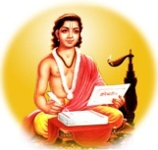
Sant Dnyaneshwar Shikshan Sanstha, Islampur’s
Hon. Shri. Annasaheb Dange Arts, Commerce and Science College Hatkanangale, Dist-Kolhapur (Ms)

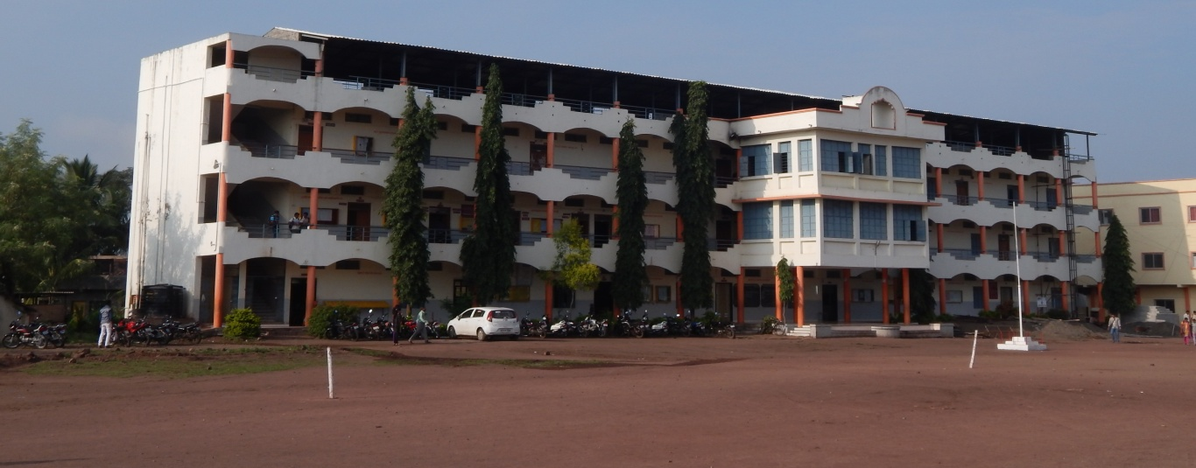

Website– www.adcacs.in. Phone- (0230)2483521
Est. June 1998

Silver Jubilee Year Program
Sr. No. | Title of Activity | Convener/Organizer | Date
1 | Orientation on Morals and Ethics in Journalism (Felicitation of Journalists from Print Media ) | Mr. Ravindra Patil  Mr. Raygonda Mudhole
2 | Eye Check-up Camp (Free Check-up and spreading awareness about Eye disorder) | Mr. Ramesh Patil | pending
3 | Her Ghar Tiranga Rally under Azaadi Ka Amrit Mahotsav program (fostering national unity and instilling deep sense of patriotism) | Dr. Sunita Telsinge
4 | Exhibition and Poster Display on Remembering Pains of Partition under Azaadi Ka Amrit Mahotsav program | Dr. Niranjan Kulkarni
5 | Tree Plantation Program (Spreading awareness about saving the environment & beautifying our life and surroundings) | Dr. Sunita Telsinge
6 | Lecture on Professional Ethics in Teaching profession (Felicitation of Headmasters from nearby Schools) | Dr. Mohan Sawant
7 | Felicitation of Village Heads and Members of Village Councils (Orientation of citizens and students about public & political ethics) | Dr. Mohan Sawant | pending
8 | Book Exhibition (Stand-on Book Discussion, Reading excerpts from famous book, encouraging students, etc) | Mr. Balaji Kamble
9 | Entrepreneurship Conference (Encouraging students for modern farming and self business) | Dr. Ashok Jadhav
10 | Celebration of Constitution Week of India (Orientation of students on the constitution of India, rights and responsibilities of citizen, human values such as liberty, equality, fraternity, etc) | Dr. Appasaheb Shelke
11 | Organizing Farmers Meet (Knowledge of Agriculture, agro-business and respecting Farmers) | Mr. Shankarrao Mohite
12 | Organization of Women’s Festival (Women Empowerment, Women Health issue orientation, Gender Equity, etc) | Dr. Sanghmitra Sarwade
13 | Organization of Health Check up Camp (Hygiene awareness and detection of disorder) | Mrs. Sarita Koli
14 | Organization of Science Exhibition (Instilling scientific approach and awareness of the field of science) | Mr. Pravin Gurav
15 | Celebration of Social Justice Week (Gender Equity, Social Harmony, Love for nation, etc) | Mr. Digambar Kulkarni | Pending
16 | Blood Donation (Fostering institutional social responsibility and human values among the students) | Dr. Sunita Telsinge
17 | Silver Jubilee Closing Ceremony (Counseling, Awarding and Highlighting Achievements) | Dr. Amar Kamble

